Design Phase Report

Category: Application Development
Title: KEA – Engineering Seats Allotment

List of Team Members:
USN | ROLL NO | NAME
01FE20BCS095 | 230 | Mayuri Kalmat
01FE20BCS096 | 231 | Parag Hegde
01FE20BCS099 | 234 | Pranav Jadhav
01FE20BCS098 | 233 | Yashvardhan Diwan

Team Leader: Yashvardhan Diwan

Responsibilities:
Mayuri Kalmat | ER diagram 1, Problem Statement, Documentation
Parag Hegde | ER diagram 3, Relational schema
Pranav Jadhav | ER diagram 2, Data dictionary
Yashvardhan Diwan | Normalization, Table creation

All four members have done the finalized ER diagram.

Problem Description: We have chosen KCET counselling as the real-world problem. In Karnataka, KEA is the authority that manages the counselling and admission of students to the professional courses after their class XII. During these Covid times, it is nearly impossible for the students to take part in the offline counselling. So, to overcome this problem, we have designed an online KEA counselling database in the favor of students, using SQL.

Requirements Specification: There are no any specific changes in our previous and current Entity Relationship (ER) diagrams.
Design Questions to be answered
Question 1: From the problem description, identify the entities that need to be represented in the database, the attributes of each entity, the relationships between the entities, and the cardinality ratios of each relationship.
STUDENT: App_no, S_Ph_no, S_state, Address, S_name, Age, Gender, email
STUDENT_CREDENTIALS: CET_No, Rank, Quota, Password
COLLEGE: C_id, C_Name, C_City, C_Ph_No
BRANCH: B_id, B_Name, Category _Seats
CHOICE: User_id, Ch1, Ch2, Ch3, Ch4
GUARDIAN: G_Name, Income, G_Ph_No, G_Aadhar_No, G_State, Mtr_Tongue
ADMITTED: Fees, App_No, C_id,
Relationships with cardinality ratio (Relationship underlined)
- Student owns Student credentials. (1:1)
- Student allotted to college. (M: N)
- College consists of branch. (1: N)
- Student has Guardian. (1: N)
- Student enters Choices. (1: N)

Question 2: Draw an Entity-Relationship Diagram illustrating the information you have identified in Question 1.

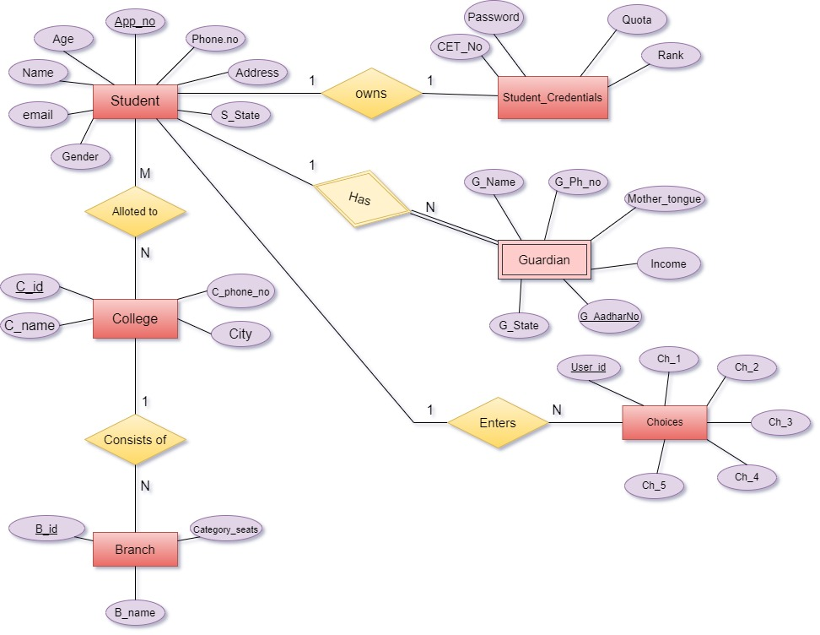
ER Diagram 1

Question 3: Draw alternate Entity-Relationship Diagram illustrating the information you have identified in Question 1 that you think are most likely to occur.
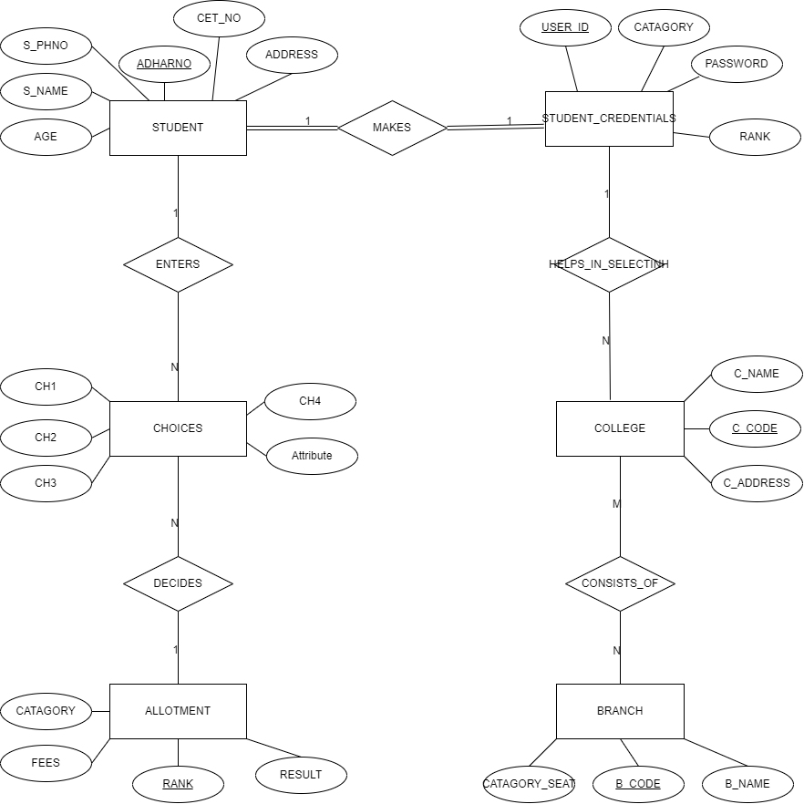
ER diagram 2
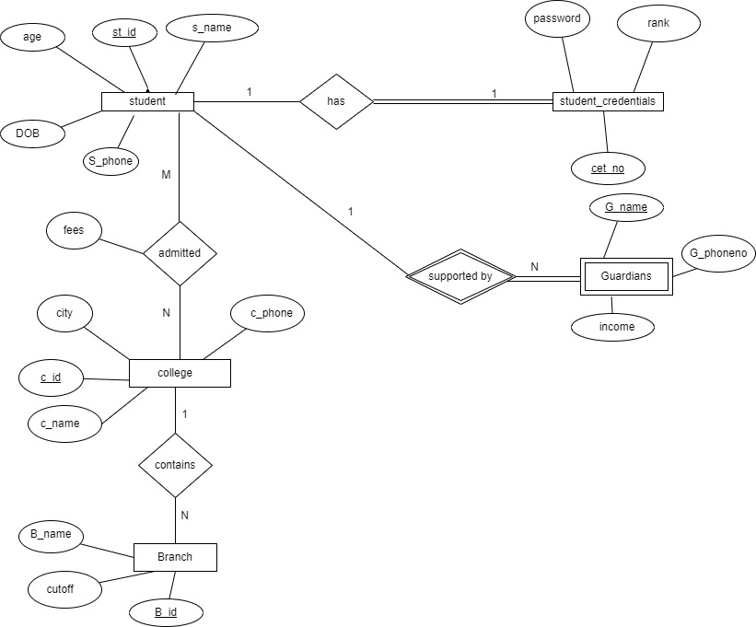

ER diagram 3

Question 4: Choose the optimal Entity-Relationship Diagram from the designs provided above and justify why you think this is an optimal solution for your identified problem specification.
ANSWER FOR CHOICE AND JUSTIFICATION
OPTIMAL ER DIAGRAM

JUSTIFICATION-: Clear mention of all cardinality ratios, use of appropriate entities , proper participation types, clear description of the relationship.
[Optional] Question 5: Draw an Object Model illustrating the information you have identified in Question 2.
DRAW YOUR OBJECT MODEL DIAGRAM HERE

Question 6: Draw an ER to Relation Mapping illustrating the information you have identified in Question 4.
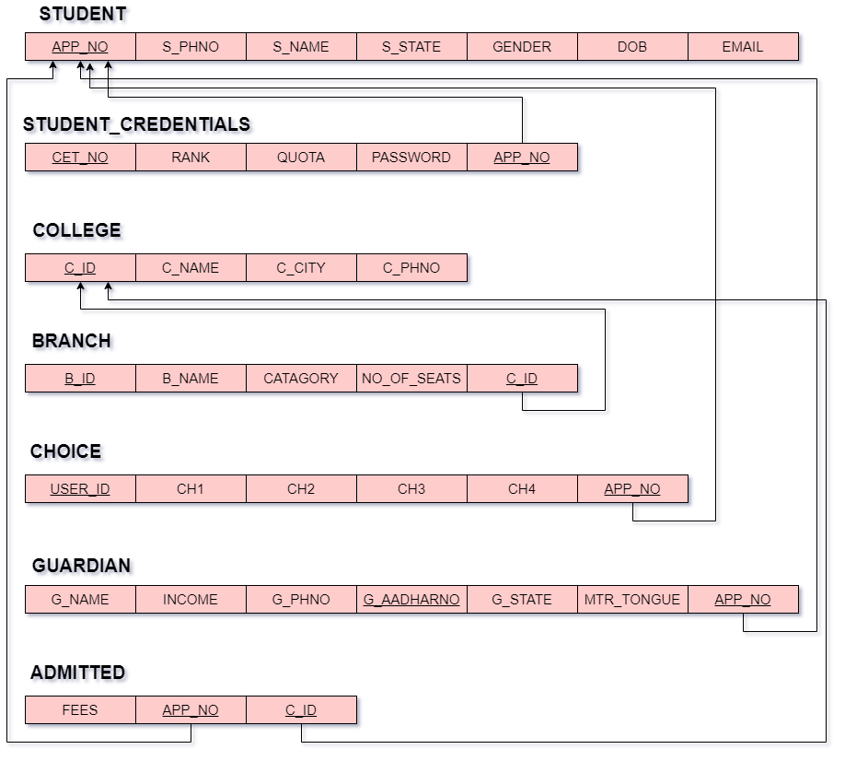
ER TO RELATIONAL MAPPING DIAGRAM

Question 7: Draw a Data Dictionary illustrating the information you have identified in Question 6.
Object  (Entity) | Name  (Attribute) | Type | Description | Primary Key | Foreign Key
STUDENT | App_No | Varchar | Student’s  CET Application number | YES | NO
STUDENT | S_Name | Varchar | Name of student | NO | NO
STUDENT | S_Phno | Integer | Student’s contact  number | NO | NO
STUDENT | S_State | Varchar | State name where the student resides. | NO | NO
STUDENT | Gender | Varchar | States the gender of the student. | NO | NO
STUDENT | DOB | Date | Student’s date of birth. | NO | NO
STUDENT | Email | Varchar | Student’s email address. | NO | NO
STUDENT_CREDENTIALS  STUDENT_CREDENTIALS | CET_No | Varchar | Student’s CET Hall-ticket number. | YES | NO
STUDENT_CREDENTIALS  STUDENT_CREDENTIALS | Rank | Integer | Rank obtained by the student in the CET exam. | NO | NO
STUDENT_CREDENTIALS  STUDENT_CREDENTIALS | Quotas | Varchar | Specifies the privileged quota such as NCC, army, rural etc, (If any) | NO | NO
STUDENT_CREDENTIALS  STUDENT_CREDENTIALS | Passwords | Varchar | Password used by the students to log into their accounts. | NO | NO
STUDENT_CREDENTIALS  STUDENT_CREDENTIALS | App_No | Varchar | Student’s  CET Application number. It references the STUDENTS table. | NO | YES
COLLEGE | C_ID | Varchar | It is a unique id assigned to each college. | YES | NO
COLLEGE | C_Name | Varchar | Official name of the college. | NO | NO
COLLEGE | C_City | Varchar | Specifies the location where the college is situated. | NO | NO
COLLEGE | C_Phno | Integer | Contact number of college office. | NO | NO
BRANCH | B_ID | Varchar | A unique id assigned to each branch. |  | NO
BRANCH | B_Name | Varchar | Branch Name. | NO | NO
BRANCH | Category | Varchar | Specifies the category to which the student’s caste belongs. | NO | NO
BRANCH | No_of_seats | Integer | Specifies the number of seats distributed according to the categories. | NO | NO
BRANCH | C_ID | Varchar | It is a unique id assigned to each college. It references COLLEGE table. |  | YES
CHOICE  CHOICE | User_ID | Varchar | Student’s user id to  log-in. | NO | NO
CHOICE  CHOICE | Ch_1 | Varchar | Choice of colleges entered by the student in the choice entry. | NO | NO
CHOICE  CHOICE | Ch_2
CHOICE  CHOICE | Ch_3
CHOICE  CHOICE | Ch_4
CHOICE  CHOICE | Ch_5
CHOICE  CHOICE | App_No | Varchar | Student’s  CET Application number. It references the STUDENTS table. | YES | YES
GUARDIAN | G_Name | Varchar | Guardian’s Name. | NO | NO
GUARDIAN | Income | Integer | Specifies the income as per the income tax certificate. | NO | NO
GUARDIAN | G_Phno | Integer | Guardian’s Contact Number. | NO | NO
GUARDIAN | G_AadhaarNo | Varchar | Guardian’s Aadhaar Number. | YES | NO
GUARDIAN | MTR_Tongue | Varchar | Specifies the student’s mother tongue. | NO | NO
GUARDIAN | G_state | Varchar | Specifies the domicile. | NO | NO
GUARDIAN | App_No | Varchar | Student’s  CET Application number. It references the STUDENTS table. | YES | YES
ADMITTED | Fees | Integer | Specifies the fees for every college. | NO | NO
ADMITTED | App_No | Varchar | Student’s  CET Application number. It references the STUDENTS table.  Denotes which student has been allocated which college | YES  (Both together) | YES
ADMITTED | C_ID | Varchar | It is a unique id assigned to each college. It references COLLEGE table. | YES  (Both together) | YES

Question 9: Normalization: Are all the relations in your chosen schema in 3NF? Are they in BCNF? Explain your answers. If any of your relations are not in BCNF, normalize them to BCNF. If you choose to normalize your relations only till 2NF or 3NF, explain your reasons (e.g., the amount of redundancy introduced is limited or some other valid reason).
1.STUDENT
(App_no, S_name, S_state, Phone_no, age, DOB, E-mail)
- The relation is in 1NF because there are no attributes that can hold more than
one values. The attributes are holding only atomic values.
- The relation is in 2NF as the primary key contains only one attribute, hence
every attribute in the relation is fully functionally dependent on the primary key.
- The given relation is in 3NF because there are no any transitive functional
dependency.
- The given relation is in BCNF there are no non-prime attributes determining
non-prime attribute.

2.STUDENT_CREDENTIAL
(Cet_no, App_no , password , rank, quota)
- The relation is in 1NF because there are no attribute having multiple values.
The attributes are holding only atomic values.
- As the primary key (set_no,app_no) can determine all other attributes and
there is no any partial dependency hence the relation is in 2NF.
- The given relation is in 3NF because there are no any transitive functional
dependency.
*The given relation is in BCNF there are no non-key attributes determining non-key attribute.
3. COLLEGE
(C_id, C_name, C_city, C_phone)
- The relation is in 1NF because there are no attribute having multiple values.
The attributes are holding only atomic values.
- As the primary key can determine all other attributes and there is no any partial
dependency hence the relation is in 2NF.
- The given relation is in 3NF because there are no any transitive functional
dependency.
- Similarly given relation is in BCNF there are no non-key attributes
determining non-key attribute.
4. BRANCH
(B_id,C_id,B_name,GEN,OBC,SC)
- The relation is in 1NF because there are no attribute having multiple values.
The attributes are holding only atomic values.
- As the primary key can determine all other attributes and there is no any partial
dependency hence the relation is in 2NF.
- The given relation is in 3NF because there are no any transitive functional
dependency.
- The given relation is in BCNF there are no non-key attributes determining
non-key attribute.
5.CHOICE
(User_id, App_no, ch_1, ch_2, ch_3, ch_4)
- The relation is in 1NF because there are no attribute having multiple values.
The attributes are holding only atomic values.
- As the primary key can determine all other attributes and there is no any partial
dependency hence the relation is in 2NF.
- The given relation is in 3NF because there are no any transitive functional
dependency.
- The given relation is in BCNF there are no non-key attributes determining
non-key attribute.
- GUARDIAN
(App_no, G_Adharno, G_state, income, G_phno, Mother_tongue)
- The relation is in 1NF because there are no attribute having multiple values.
The attributes are holding only atomic values.
- As the primary key can determine all other attributes and there is no any partial
dependency hence the relation is in 2NF.
- The given relation is in 3NF because there is no any transitive functional
dependency.
- The given relation is in BCNF there are no non-key attributes determining
non-key attribute.
7.ADMITTED
(App_no, C_id, fees)
- The relation is in 1NF because there are no attribute having multiple values.
The attributes are holding only atomic values.
- As the primary key can determine all other attributes and there is no any partial
dependency hence the relation is in 2NF.
- The given relation is in 3NF because there are no any transitive functional
dependency.
- The given relation is in BCNF there are no non-key attributes determining
non-key attribute.
References: We have made use of designing websites like:
draw.io ( https://www.draw.io/ )
Diagrams.net ( https://app.diagrams.net/ )
MS Word
SQL database

